Experiment-08
Hospital Appointment Booking System
AIM:
To develop an online hospital appointment booking website using HTML, CSS, and JavaScript to search for hospitals and doctors based on location and specialty. The system allows patients to book appointments, view appointment history, and enables administrators to manage doctors and appointments.
Procedure:
- Create an HTML form for patient details.
- Add doctor selection and appointment date fields.
- Design the page using CSS.
- Use JavaScript to validate patient details.
- Display the appointment confirmation.
Sample Code:

<!DOCTYPE html>
<html>
<body>
<h2>Hospital Appointment Booking</h2>
<input id="patient" placeholder="Patient Name">
<select id="doctor">
<option>Cardiologist</option>
<option>Dermatologist</option>
<option>General Physician</option>
</select>
<input type="date" id="date">
<button onclick="book()">Book Appointment</button>
<p id="result"></p>
<script>
function book() {
let p = document.getElementById("patient").value;
let d = document.getElementById("doctor").value;
let date = document.getElementById("date").value;
if (p && date) {
document.getElementById("result").innerHTML =
"Appointment booked for " + p + " with " + d + " on " + date;
} else {
document.getElementById("result").innerHTML =
"Enter all details";
}
}
</script>
</body>
</html>

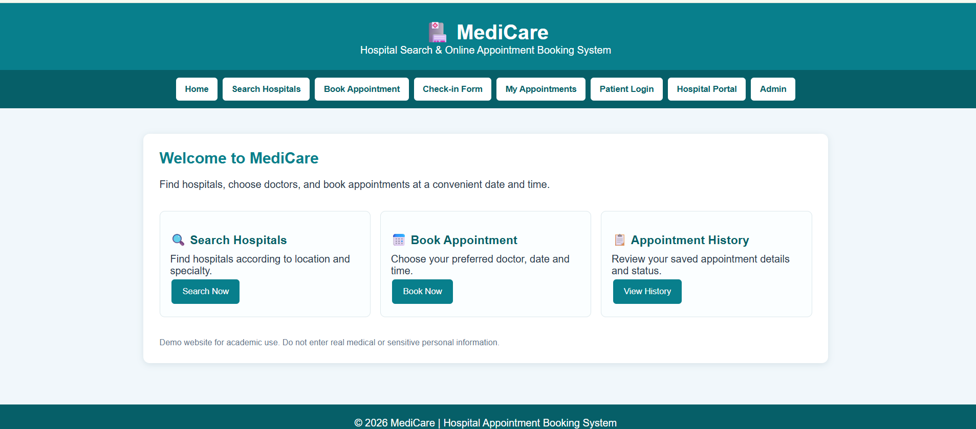
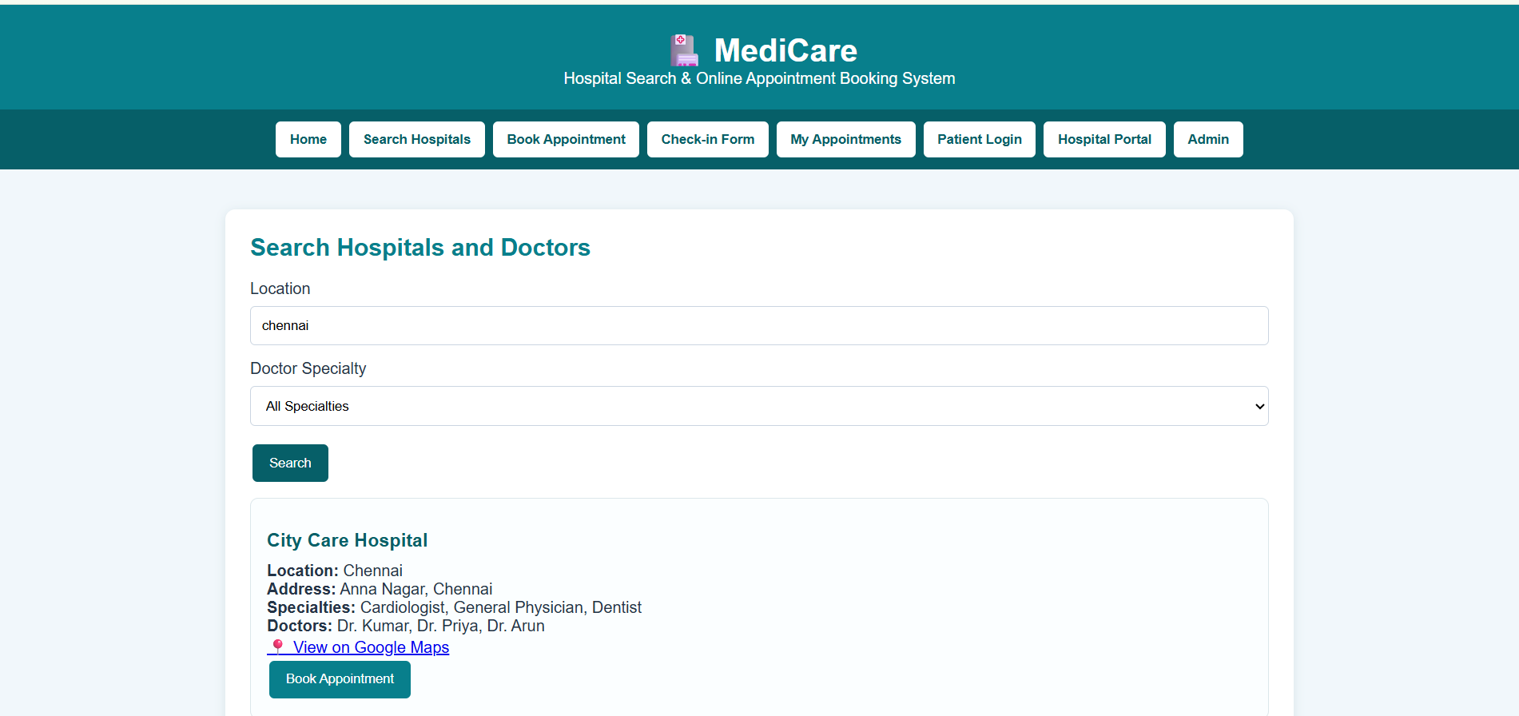
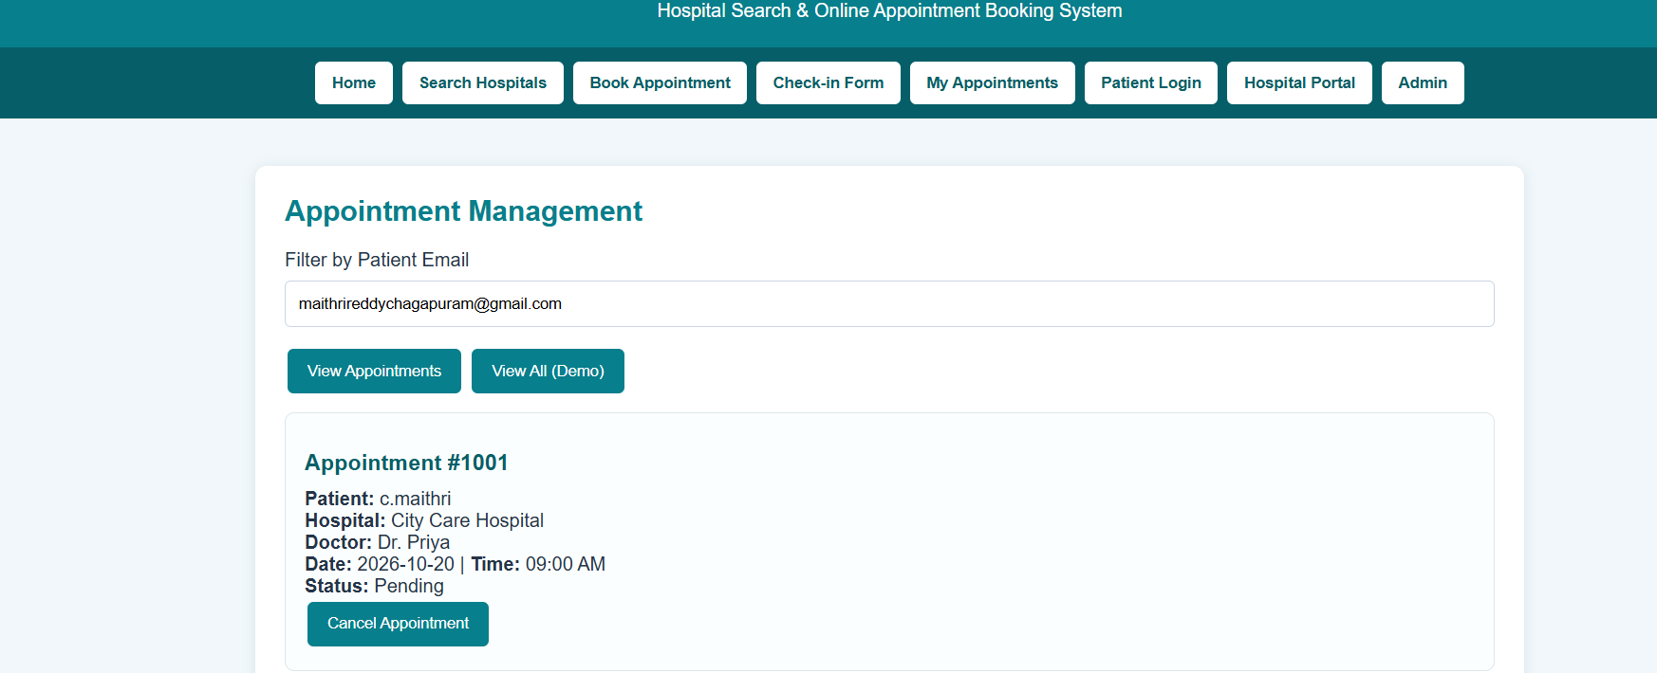
Result:
Thus, the hospital appointment website was developed successfully to select a doctor, enter patient details, and display appointment confirmation.

